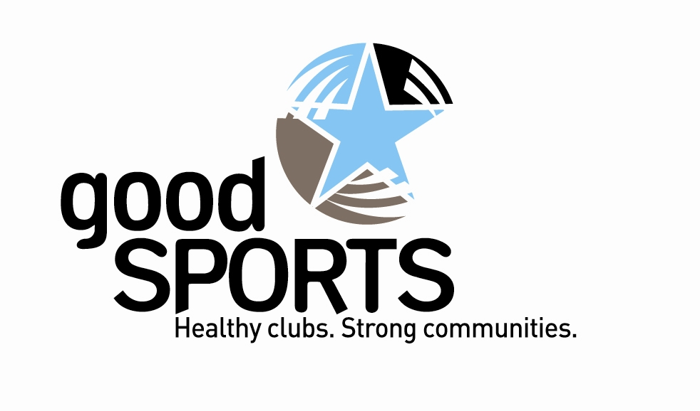

Stella Clavisque Club

JOINS GOOD SPORTS PROGRAM

August 2014

Sports clubs such as ours play a significant role in the community and therefore have a responsibility to our members and their families. In recognition of this, the Stella Clavisque Club has elected to participate in the Australian Drug Foundation’s Good Sports program.

Good Sports is the first nationwide alcohol management program of its kind and is run in Victoria by Australian Drug Foundation with the support of TAC, VicHealth, Department of Human Services and the Alcohol Education Rehabilitation Foundation. The program has been designed to assist clubs with the responsible management of alcohol and is the only nationwide program of its kind.

As a community based club we believe involvement in this program is a way for our club to promote a healthy and welcoming club culture whilst working to consistently meet our duty of care obligations in regards to alcohol consumption.

To become Good Sports Level 1 accredited we will address a number of criteria including having Responsible Serving of Alcohol trained bar staff and our facilities will be smoke free.

For more information about the Good Sports program contact Paul Lesur.

